Using the Sway Presentation
Why use Sway?
This presentation was designed in Sway to provide maximum flexibility to instructors. By using Sway, students can access the presentation, all reading, and media files at their desk through a laptop, tablet, or cell phone. This makes Sway presentation compatible with e learning and provides students flexibility with devices at home.
How to use Sway?
Step 1: Open the Sway presentation by going to https://sway.office.com/cEXT4OpQrKTazaDX?ref=Link
OR
Insert the below visual link into your school’s Student Management System for students or an email.
Little Haiti: Exploring Haitian American Community and Identity Through Art
Students will be able to explore the concept of enclave communities
Go to this Sway

Step 2: Play the Sway presentation by clicking PLAY at the top right corner of the screen.
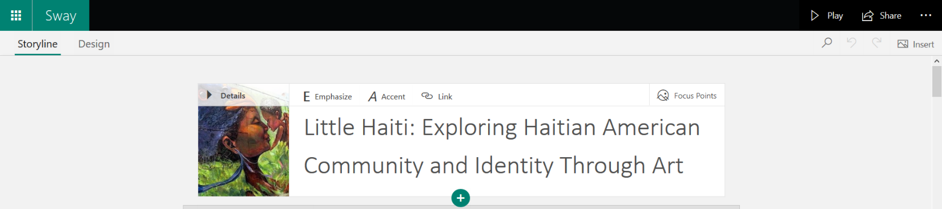

Step 3: Move through the Sway presentation using the icons in the bottom right corner of the screen.
Navigate to a particular location or chapter in the presentation by clicking on the symbol. The click on the location you are interested in researching.
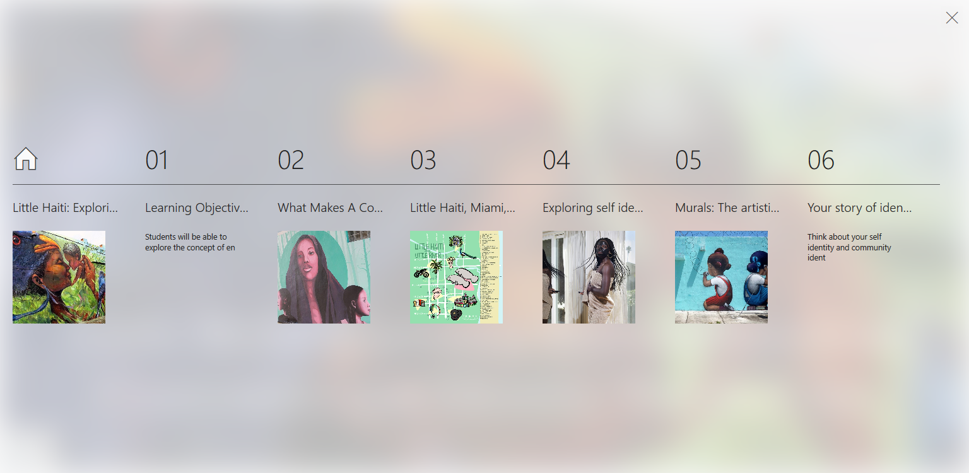

It’s that easy!

