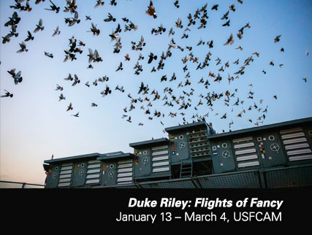

Duke Riley: Flights of Fancy
http://ira.usf.edu/CAM/exhibitions/2017_1_Duke_Riley/Duke_Riley.html

Annotated Bibliography: Teaching Resources
Prepared by:
Bárbara C. Cruz
Cheryl Ellerbrock
Sarah Mead

The show incorporates two projects from Duke Riley: “Fly by Night” (2016) and “Trading with the Enemy” (2013). Below are resources dealing with these shows specifically, as well as general information about the artist.

Print Resources (books, articles, curriculum guides, etc.)

Adams, J.N.P., Worwood, K., Atkinson, D. Dash, P., Herne, S., & Page. T. (2008). Teaching through contemporary art: A report on innovative practices in the classroom. London: Tate Publishing.
Based on a one-year research project conducted in schools in London and Liverpool, this book presents innovative instructional approaches to teaching and learning in schools through contemporary art practices. The emphasis is on the practical, day-to-day application of teaching methods with contemporary art in the classroom.

Boucher, B. (2009). Duke of hazards. Art in America 97(10), 158-165.
Review of Duke’s performance piece, Those About to Die Salute You, in Queens, New York.
Photos of the performance, along with his works on exhibition at the Queens Museum of Art are included.

Freedlander, D. (2010). Urban folk art. Theater 40(3), 25-41.
Performance art events in New York City are discussed, beginning with a beach party in Brooklyn orchestrated by Duke Riley. Exploring the theme of local history, Riley called his art installation Dead Horse Bay, after the glue-making industry that thrived there at the turn of the 20th century.

Klein, J., & Klein, S. (2012). What Is contemporary art?: A guide for kids. New York: The Museum of Modern Art.
Written for young adolescents, this book showcases artworks by international artists (organized thematically by subjects of interest to kids) drawn from the collection of The Museum of Modern Art. The collection reflects art across all media --- painting, sculpture, film, photography, performance, and installation.

Landi, A. (2010). Maritime Mischief. ARTnews 109(2), 73-75.

An irreverent look at Duke Riley’s art, chronicling the “meticulous planning and historical authenticity” of his works. Photos and images accompany the review, along with extended discussion on the artist’s motivations and inspiration for many of his projects.

Louise Blouin Media. (2016). Flock choreography. Modern Painters 28(5), 34.
In this article Riley explains how his inspiration for the show came about when he learned that during World War II, when Nazis used hawks to intercept carrier pigeons with military information, the Allies started flying pigeons at night instead.

New Museum. (2010). Rethinking contemporary art and multicultural education (2nd ed.). New York: Routledge.
This useful and practical book provides teachers innovative approaches and content for infusing contemporary art into the school curriculum. High-quality illustrations reflect the contributions of more than 100 artists and curators.

Smith, R. (2016, June 17). Duke Riley: ‘Fly by Night.’ New York Times 165(57266), C16.
This article reviews and offers information on Riley’s light show Fly By Night. The piece, shown at the Brooklyn Navy Yard in Brooklyn, New York City, showcased lighted pigeons circling a boat.

Venäläinen, P. (2012). Procedia 45, 457-465.
This article explores how the role of art in schools has both changed and remained the same over the course of the last 50 years. The author argues for the use of contemporary art as a learning experience in and of itself.

Zorich, Zach. (2011). An artist of the ignored world: Duke Riley tells the history of people and places on society's margins. Archaeology 64 (3), 18-19.
This brief interview with Duke Riley explores the artist’s for creating his archaeological work, Reclaiming the Lost Kingdom of Laird, which reconstructs the history of a 400-acre island in the Delaware River and the telling of one family's story as if they were royalty using mosaics, paintings, and a series of commemorative plates. In this interview, Riley discusses the culture of waterfronts and transient people.

The Smugglers & the Filmmakers
http://ira.usf.edu/PDFS/DukeRiley-FilmmakersSmugglersGuide.pdf
This “pigeon bio” resource includes images and descriptions of each of the characters that make up Duke Riley’s work, Trading with the Enemy. This installation referencing the US trade embargo on Cuba, includes videos filmed by the birds, which Riley named after smugglers and filmmakers who ran afoul of the law.

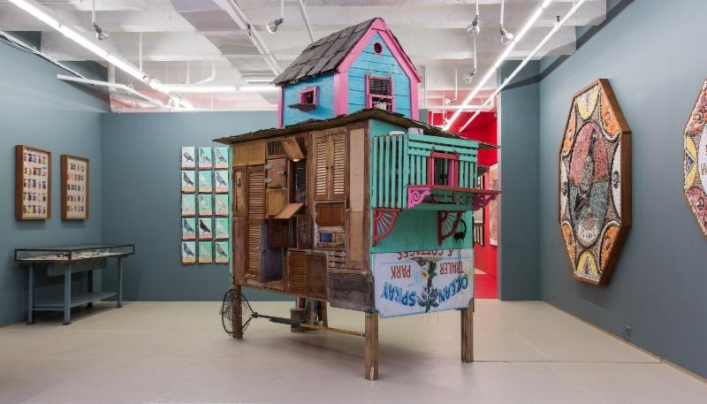

Online Resources (online articles, interviews, galleries, etc.)

Duke Riley Official Website
http://www.dukeriley.info
Duke Riley’s main website features a biography and artist statement along with a list of projects, exhibitions, commissions, collaborations, and links to recent articles from the press.

Review: 'Duke Riley: Flights of Fancy' at USF connects people with pigeons
http://events.tbo.com/things-to-do/visualarts/review-duke-riley-flights-of-fancy-at-usf-connects-people-with-pigeons/2311794
In this Tampa Bay Times article, the author provides an overview and review of USF CAM’s Duke Riley exhibition.

“2,000 Pigeons Will Put on a Light Show in Brooklyn”
https://www.nytimes.com/2016/04/29/arts/design/-duke-riley-pigeons-fly-by-night.html
In this New York Times article, Duke Riley describes his “Fly by Night” exhibition. The article also talks about his 2013 exhibition “Trading with the Enemy”.

Fly by Night Project
http://creativetime.org/projects/flybynight/
This website features, among other things, an in-depth documentary about Duke Riley’s world-renowned artwork Fly By Night, photos of the event, information about Riley, information about the navy yard, and information about the pigeons including profiles of each.

Review: In ‘Fly by Night,’ Pigeons Light Up the Brooklyn Navy Yard
https://www.nytimes.com/2016/05/09/arts/design/review-in-fly-by-night-pigeons-light-up-the-brooklyn-navy-yard.html?_r=0
In this New York Times article, the author provides an overview and review of Duke Riley’s Fly by Night performance.

Pigeon Protest: Free the Brooklyn Navy Yard 2,000
https://mobile.nytimes.com/2016/05/19/arts/design/pigeon-protest-free-the-brooklyn-navy-yard-2000.html
In this New York Times article, the author elaborates on the reasons people protested Duke Riley’s Fly by Night performance.

“Avian Artistry, With Smuggled Cigars”
http://www.nytimes.com/2013/10/17/arts/design/avian-artistry-with-smuggled-cigars.html
Brooklyn Artist Trains Pigeons to Smuggle Cuban Cigars
https://www.youtube.com/watch?v=mBVUc_d1-tQ
This New York Times article highlights aspects of Riley’s project, “Trading with the Enemy” and the video complements the article.

“Artist Challenges Genesis of Duke Riley’s Illuminated-Pigeon Project”
https://www.nytimes.com/2016/05/28/arts/design/artist-challenges-genesis-of-duke-rileys-illuminated-pigeon-project.html?_r=0
In this New York Times article, Dutch artist Jasper van den Brink suggests that he originally thought of the pigeon project.

Magnanmetz Artist Feature: Duke Riley
http://www.magnanmetz.com/artists/duke-riley
This gallery’s web page on Riley includes biographical information, images of his artwork, and PDFs of interviews, articles, reviews, and more.

Fly Away Home With Pigeons
https://www.wsj.com/articles/fly-away-home-with-duke-rileys-pigeons-1461595496
This Wall Street Journal article highlights Duke Riley’s Fly by Night exhibition and includes a virtual reality 360 degree video.

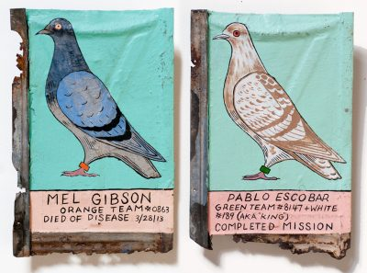

Video Resources (films and video clips that can be rented, purchased, or found online)
*Listed in order of time/length

Duke Riley, Fly By Night (1:23)
https://vimeo.com/165814692
This video appears to come from an individual in the audience using a smartphone camera. Unlike the other videos, it is a full minute of the pigeon’s flight over the New York skyline with no additional sound or overlays.

Duke Riley—Trading with the Enemy PREVIEW (1:51)
https://vimeo.com/70947868
Gain a glimpse of the pigeons’ flight from Key West to Havana. Facts regarding the U.S. Embargo to Cuba are provided

Juxtapoz presents Duke Riley Part 1 (2:44)
https://www.youtube.com/watch?v=AIZdATkQNoo
A brief clip introduces the artist and his project, “After the Battle of Brooklyn” (2007) project. In this clip, Duke Riley launches a revolutionary era submarine to investigate a new British ship in the New York Harbor.

Juxtapoz presents Duke Riley Part 2 (2:24)
https://www.youtube.com/watch?v=iJKTtBNqovw
A brief clip continue a description of the artist and introduces the “Those About to Die Salute You” project in which New Yorkers from each of the five boroughs recreate a Roman style naval battle in an empty basin left over from the World’s Fair.

Flight of the Pigeon (3:33)
https://vimeo.com/175241289
This video highlights the artist’s interest in pigeons. Hear commentary from Duke Riley overlaid on captivating scenes of the LED flights of the pigeons.

Democracy Now! Trading with the Enemy Report (4:18)
https://www.youtube.com/watch?v=FxdxnswD1U4
Democracy Now! Reports on Duke Riley’s “Trading with the Enemy” (2013) project in August of 2015 as then Secretary of State John Kerry was traveling to Cuba to open the U.S. Embassy in Havana. A brief interview with the artist describes the pigeon training process and discusses the “Trading with the Enemy” Act (TWEA of 1917).

‘Fly By Night’ Pays Homage to Pigeon Keeping (4:23)
https://www.youtube.com/watch?v=t8m7_09kd-I
Another perspective from the “Fly By Night” (2016) show offers interviews with attendees of the show at the Brooklyn Naval Yard. A clip from an interview with the artist encourages viewers to get off of their phones for a moment and look up at the sky. Duke Riley also mentions his own experience living in a pigeon coup for four years, as well as makes reference to the use of pigeons by the U.S. military during WWII to deliver messages to ships.

LED Pigeons Light Up the Brooklyn Sky (5:49)
https://www.youtube.com/watch?v=yE_RBqCW49U
Interview with Duke Riley describing “Fly By Night” (2016) project and the symbolic and historical use of pigeons in this work. Clips within the video showcase the lighting spectacle and detail the process of setting up this project. Themes of human connection with nature are addressed.

Creative Time Presents Duke Riley’s Fly By Night (13:57)
https://vimeo.com/196804459
Follow Duke Riley and his creative team and support crew through the planning phases of “Fly By Night” (2016). Duke Riley reminisces about his relationship with pigeons, the cultural practice of pigeon keeping, and his fascination with the urban waterfront. Watch the wonder of the crowd on opening night in Brooklyn. Be careful… this video will make you want to be a pigeon keeper! There are two curse words, so be sure to preview prior to showing students. This video is an excellent summary of the “Fly By Night” project if you have the class time.

